Disabling the Touch Screen
- Go to the Windows Button (START) and then Control Panel
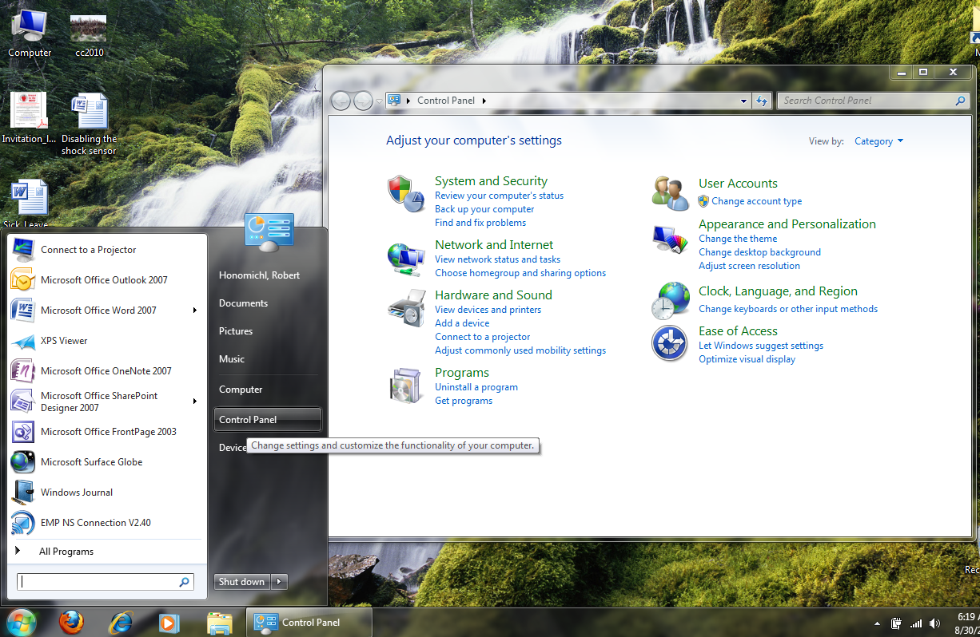
- Click Hardware and Sound
- Then Click on Change tablet pen settings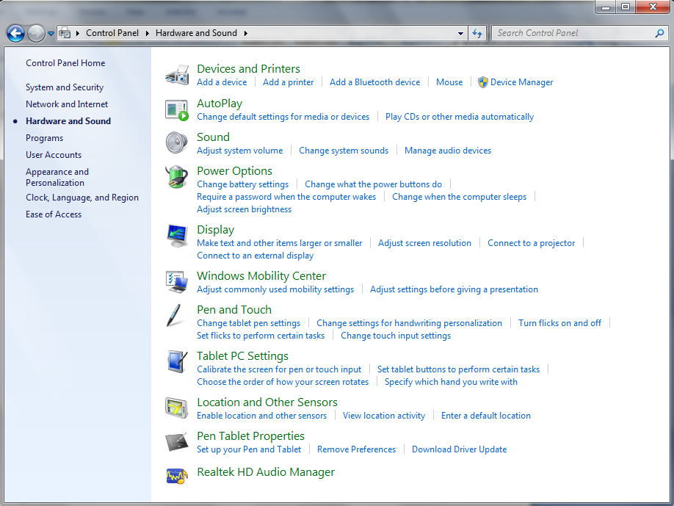
- Then click on the touch tab and uncheck Use your finger as an input device. This will still allow your stylus to be used. Then Click OK.